Introduction: How Trauma Hides in Everyday Life
“Show me a sane man and I will cure him for you.”
― Carl Gustav Jung ¹
In my practice, I see many people seeking answers for chronic pain. If that's you, you're not alone. By the time they walk through my door, they've often spent months—or even years—searching for an explanation. They've seen doctors, undergone countless blood tests, had scans and specialist appointments, yet the results often fail to fully explain what they're experiencing. Their tests may be normal, or they may show changes that don't account for the severity of their symptoms. Either way, their pain is very real.
Despite numerous investigations and treatments, their back still aches. Their body seems constantly braced. They're exhausted from broken, unrefreshing sleep. To add insult to injury, they're often dismissed, hearing phrases like, "Your tests are fine," or worse, "Perhaps it's all in your head." They wonder, Can I trust my own body?
Here's what I tell them: your body may be responding to an injury, illness, or disease, but it may also be trying to tell you something else—something you haven't been able to hear. Years of pushing through, ignoring your needs, or disconnecting from difficult feelings have made it hard to recognise what your body is communicating. Learning to listen to your body—and work with it—is part of the path to healing.

For many people living with persistent or unexplained pain, part of what the body is carrying may be the impact of trauma.

A patient of mine, Sarah, was so used to bracing for danger that it felt normal. She had grown up in a family where there was a right way and a wrong way to be. Stray too far from what was expected and you risked criticism, punishment, or rejection. More than anything, Sarah wanted to feel loved and accepted by her family. But she also desperately wanted the freedom to be herself. So, she spent much of her childhood trying to solve an impossible conflict: How can I be myself without losing the people I need?
Sarah thought she had done a pretty good job of surviving it all. Somehow, through everything, she had held on to a fiercely independent, creative part of herself that refused to submit. She grew up, raised a family of her own, survived two difficult marriages, and built a life as an artist.
She thought she had left the past behind.
But her nervous system hadn't.
Decades later, her body was still bracing. She worried about doing the wrong thing, making mistakes, or disappointing people. She remained tense and vigilant, as though criticism or rejection might come at any moment. She rarely felt relaxed or truly safe.
She also began experiencing sudden, sharp pain in her back. She might be having dinner with family or spending time with friends when, out of nowhere, it felt as though someone had kicked her in the back. Was it lingering nerve pain from shingles? Could it be fibromyalgia? The doctors couldn't really explain what was causing Sarah’s pain and the pills they prescribed barely made any difference. None of it made any sense.
Sarah began to distrust her body and fear ordinary social encounters. She never knew when the next pain flare-up would strike.
Pain may begin with an injury, an illness, an operation, or a body that has simply been pushed too far. But when pain persists, something else can happen. The nervous system adapts. It goes into survival mode.
And somewhere along the way, your nervous system stops treating pain as a symptom and starts treating life itself as dangerous.
This book is about how that happens—and, more importantly, how you can begin to feel safe in your body again.

The pain you forgot
When most people hear the word trauma, they think of physical or sexual abuse, assault, or disasters: something obvious and dramatic. But many people living with unexplained illness or pain have also been affected by stressors they may not recognise as traumatic. Chronic emotional absence, disconnection, and low-level threat can affect the body just as deeply as more obvious form of trauma. ²
If things were not okay at home when you were a child, the best way to survive was to adapt to whatever was going on and pretend everything was okay. This keeps you safe in an unsafe situation. After a while that becomes your primary way of dealing with reality.
Hiding the truth from yourself protects you from pain you weren't ready to face at the time. It helps you function, keep going, and look “normal” from the outside. Strategies like these can work remarkably well—until one day they don't. Along the way, they also shape how your nervous system responds to life. And at some point, the body stops pretending.
My Story
For most of my life, I believed I’d had a normal childhood.
I came from a solid, church-going family. Predictable routines. A hot meal on the table every night. A good education. My parents stayed together, even after affection had given way to strained tolerance. Okay, emotions were not my engineer father’s language and, though dutiful, my mother sat firmly at the centre of her own universe. But on the surface, a very normal baby-boomer family.
And yet, something didn’t add up.
I carried a strange collection of physical and emotional problems: digestive issues, anxiety, skin picking, asthma and thyroid problems that appeared in adulthood. I also struggled with abysmal self-esteem and intimacy issues. Although I managed to appear friendly and outgoing, I never felt relaxed.
I felt like someone bracing for danger, though I couldn’t tell you what it was.
I did what many confused and curious people do: I turned to psychology for answers. I devoured self-help books. I went to therapy. I even chose psychology as my profession. If I could help others make sense of their pain, perhaps I could make sense of my own. Then came the moment everything shifted.
The missing piece
Early in my career, I attended a seminar on post-traumatic stress disorder (PTSD) led by Bessel van der Kolk, a leading authority on the subject and author of the aptly named book The Body Keeps the Score.
He listed the hallmarks: ongoing hypervigilance, difficulty relaxing, emotional numbing, intrusive thoughts, avoidance, and the way these patterns often lead to long-term health problems.
As he spoke, I felt a mixture of shock and recognition.
He was describing me!
That made no sense. I hadn’t been abused. I hadn’t survived a disaster. I hadn’t witnessed domestic violence. How could this be?
That moment marked the beginning of a long, uncomfortable search for answers. Is trauma just something war veterans or survivors of physical abuse suffer? Or something more? Why does the body react so strongly to certain kinds of stress, and how do we end up carrying the effects of the past without knowing it?
My discovery changed the way I understood pain, both in my patients and in myself.
Neuroscience is helping us understand why. A 2026 paper by neuroscientists Steven Kotler, Michael Mannino, Glenn Fox, and Karl Friston argued that trauma is not literally stored in the body but continually generated by a brain that has become stuck in threat mode.³
You don’t need to have lived through a war, an assault, or a catastrophe to develop post-traumatic stress symptoms.
The nervous system can also be overwhelmed by far more ordinary experiences: emotional neglect, chronic criticism, feeling like there’s no one to turn to. ⁴
These experiences often don’t register as “trauma” because they are not generally labelled that way. They are simply minor obstacles to be pushed through. You have to get on with figuring out what you want to do with your life: buying a home, having a family and saving enough money for retirement. Succeeding in even one of these feels like proof that you are fine.
Until one day it all falls apart.
Why Is It So Hard to See?
One of the main reasons trauma goes unrecognised is something the nervous system does very well: it helps us forget what we could not handle at the time.
Most people have experienced this to some degree: periods of life they cannot fully remember, reactions that seem disproportionate, or a persistent sense of numbness they cannot explain. At times, people may respond in ways that feel disconnected from the present moment or struggle with emotional numbness.
These symptoms are not failures of character or willpower. They are intelligent survival responses: the nervous system doing the best it could with what it had at the time while simultaneously alerting you to what’s unfinished.
Beyond pain
Healing doesn’t necessarily becoming completely free of pain – just changing its place in your life – and sometimes that’s enough.
As one of my patients with treatment-resistant pain said recently, “I still hurt, but I have learned not to pay so much attention to it and focus on what I can do.”
The key is that he discovered this as a result of his own experience, after battling with severe depression and suicidality, not because someone told him to.
Healing also means becoming whole again, in the original sense of the word. Many people describe this as a growing sense of peace and coherence: feeling more present, less pulled in different directions, and less dominated by pain and anxiety. As you begin to feel safer, you may rediscover parts of yourself that were pushed aside in the struggle to survive. You become less divided and more fully yourself.
Think of it as a healing journey. Throughout this book I'll introduce a practical roadmap that traces the journey from survival to wholeness. While every person's path is unique, healing often unfolds through a series of recognisable stages: creating safety and regulation, making sense of what has happened, mourning what has been lost, integrating those experiences into a more coherent sense of self, and ultimately rediscovering the person you were always capable of becoming.
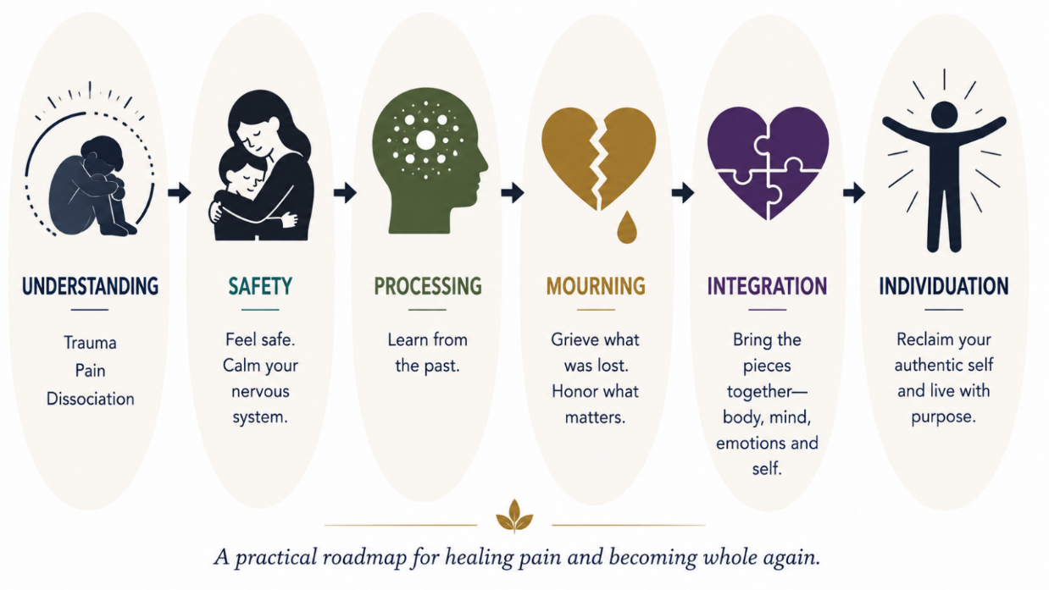

Figure 1. From survival to wholeness
This is not a book of quick fixes (“just learn to meditate”) or magical thinking (“stop catastrophising”). It’s a trauma-informed, research-grounded process that will help you understand and let go of the body memories that are maintaining your pain.
It’s not about digging up the past for its own sake or reliving what you worked hard to survive. It’s not about teaching you how to suppress your feelings; you have done enough of that.

Let’s begin.

